Impact Paper

This paper will discuss the emerging technology Edge Computing, its applications, and its ability to improve the sustainability of computing. Edge Computing describes the decentralization of the computations traditionally done in a Data Center, closer to or at the location of the device that requires said computations. The location of the computations on he Edge enables several rising trends in Information and Communication Technology(ICT) such as Mobile Computing, the Internet of Things, and Autonomous Vehicles. In addition, Edge Computing has the ability to increase the sustainability of the ICT by lowering energy cost of the network and more efficiently using edge resources.

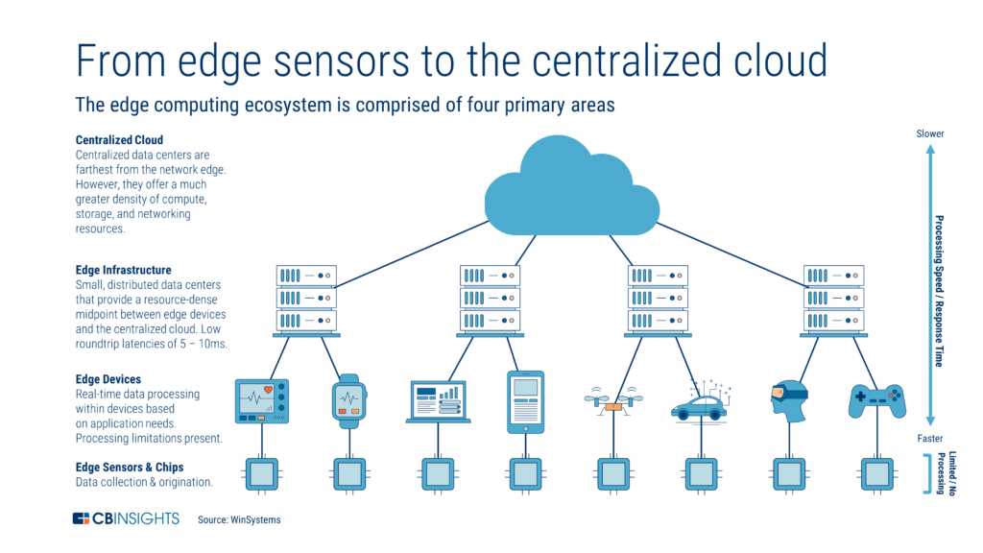 The Standard Convention of the ICT is known as Cloud Computing. In Cloud Computing the large majority of computations are done in Data Centers. In a simplistic view, a Personal Computer(PC) sends data through the Internet Network to the Center where the computation is completed. Then the result of the computation is returned through the network to the PC and the interaction is completed The Edge refers to devices users commonly interact with, such as PCs, smart phones, and video game consoles, as well as the infrastructure those devices interact with. A visual representation of the hierarchy is shown in Figure 1. Centralized Cloud Computing grew to be the norm as it was more efficient to compute in powerful data centers rather than the weaker systems on the Edge. Data Centers have grown larger and more efficient over the years, but as Weishon Shi describes “the bandwidth of the networks that carry data to and from the cloud hasn't increased appreciably. Thus, with edge devices generating more data, the network is becoming cloud computing's bottleneck”[2]. Edge Computing intends to help solve the issue of the tightening bottleneck by lowering the necessary communication with the central Cloud, by keeping as much computation local. This is accomplished with a Cloudlet[Alternatively also known as a Fog Node], which functions as a Cloud for the local system at the Edge. The Cloud will offload much of the computations it would traditionally perform and offload them on the Cloudlet. The location of the Cloudlet allows much larger bandwidth, allowing more data to be transferred, and lower latency, increasing response time. A study by Kiryong Ha tested the response time of facial recognition software processed in Pittsburgh through a Cloudlet and several Amazon Data Centers on the east coast, west coast, EU and Asia. The response was returned in 170 seconds from the Cloudlet, while the closest data center on the east cost responded in 225 milliseconds, while the longest response time came from the Asian center timing in at 810 milliseconds[6]. The Cloudlet’s response time was 1.3 to 4.8 times faster than the centralized cloud. The improved latency allows the Cloudlet and the devices interlinked to become much more responsive and allows an interconnectedness that wouldn’t be possible with the standard Data Center Infrastructure.

Figure 1 [1]

Consumers interact most with Edge Computing currently with mobile devices. Many modern mobile devices, such as laptops and cellphones, have their own cloudlet to do some operations on a small scale. Operating applications such as Facebook and YouTube, offload some function onto the Edge. This lessens the amount of bandwidth used to operate the task. It also has benefits apart from application functionality as “Offloading conserves energy and battery lifetime of the smartphone device by migrating energy-intensive computations to cloud[let]”[10]. Mobile Computing began the rise of Edge Computing and Cloudlets, and other new technologies have emerged from the infrastructure that mobile computing helped become widespread.

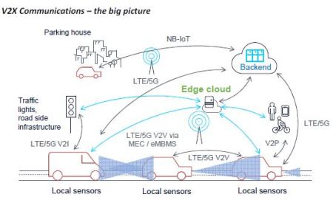Cloudlets are key for the Internet of Things (IoT), a system of interconnected objects, such as streetlights, refrigerators, thermostats, etc. The Internet of Things mimics the design of the larger ICT networks with the Cloudlet playing the part of the data center and the device components are the Edge of that system. Many of these devices have yet to be connected to the Internet, and as more devices are added to the cloud, the heavier the load on the Cloud and tighter the bandwidth. The IoT is one of the fastest expanding trends in modern computing, and the number of IoT devices are expected to reach 50 billion by 2020, outnumbering the amount of cellphones and PCs in use. The massive number of connected components and data generated would overload the current system of Data Centers[2]. Rather than interact with a Data Center, the connected components will interact with a Cloudlet, which accomplishes the desired computations much closer to the Edge device. This limits the amount of network interaction between the IoT and the Central Cloud. This is important as the load on data networks and data centers increase by 22% and 15% respectively each year[4] which will decrease the available bandwidth slowing computation speeds. In addition, the decentralized nature of Edge Computing increases the privacy of the system. In the case of a home system IoS, users are wary about data of their being sent to the cloud for computations, so a Cloudlet can accomplish much of the same tasks without interacting with Data Centers.

Figure 2 [9]

Edge Computing has also become vital in Autonomous Vehicles. Each vehicle has its own Cloudlet to complete the computations required to operate. A visualization of how a self-driving car interacts with an edge cloud is visible in Figure 2. In this model, not only is the vehicle interacting with its subsystems and sensors, but the IoT that represents other vehicles, roadway maps, and traffic signals. Due to the importance of quick responses to stimuli, such as red lights and obstacles on the roadway, the decreased latency provided by Edge computing is crucial in stopping or adjusting the vehicle in dangerous situations. The small millisecond increase in interacting with a Data Center could be the difference between the life and death of the passenger. In addition, the sheer amount of data the systems a self-driving produces, as Toyota estimates “that the data volume between vehicles and the cloud will reach 10 exabytes per month around 2025”[5] would make it impractical for the vehicle to directly interact with the Cloud. The Cloudlet also allows the vehicle to process most computations without a direct connection to the Cloud in cases where there is no wireless signal to the cloud.

Edge Computing has also been lauded for its applications in making ICT technologies sustainable. The energy consumption of ICT has been increasing over the last decade and an accelerated rate. A total consumer power consumption forecast performed by Anders Andrae forecasted that by 2025, ICT technologies will represent 20.7% of the global electricity use and 5.5% of global carbon emissions unless new initiatives are developed to improve the sustainability of the industry[8]. Historically, most of the effort in increasing energy efficiency reducing the carbon footprint has been in improving data centers. However, most of the energy consumed by ICT technologies is used in in the network transfer of data between the Center and the Edge. The Centre for Energy-Efficient Telecommunications(CEET) measured and found Wireless access network technologies account for 90% of total wireless cloud energy consumption [while] Data Centers account for only about 9%. The energy consumption of wireless user devices is negligible”[7]. Edge Computing, while it does little to decrease the total number of computations, the offloading of key programs and systems from the Cloud to the Cloudlet lessens the amount of data travelling from Edge to Center. Although the Cloudlet is not as efficient as large Data Centers in terms of computations, as shown from the CEET study, the decrease the energy consumed in the transfer of data is more necessary than decreasing the energy consumed by the computations performed within the data center.

As shown above Edge Computing and its emerging applications looks to be one of the key advancements in improving the Information and Communications Network. As the Internet of Things becomes more prevalent and representative of the ICT, Edge Computing becomes more necessary to ensure that the amount of computations such systems require do not overwhelm our current data infrastructure. The improved latency makes Cloudlets necessary in autonomous vehicles for safety. Edge Computing’s lower volume of data sent from Edge to Data Center lowers the energy cost of the ICT. As the trend of the decentralization of the ICT continues, Edge Computing will become more prevalent and a core design principle of the ICT infrastructure.

References

[1] “The Edge Computing Ecosystem: From Sensors to the Centralized Cloud.” CB Insights Research, 16 Jan. 2019, www.cbinsights.com/research/edge-computing-ecosystem/.

[2] W. Shi and S. Dustdar, "The Promise of Edge Computing," in Computer, vol. 49, no. 5, pp. 78-81, May 2016. doi: 10.1109/MC.2016.145, <https://ieeexplore.ieee.org/abstract/document/7469991>

[3] M. Satyanarayanan, "The Emergence of Edge Computing," in Computer, vol. 50, no. 1, pp. 30-39, Jan. 2017. doi: 10.1109/MC.2017.9 <https://ieeexplore.ieee.org/abstract/document/7807196>

[4] Patterson, Steven Max, and Steven Max Patterson. “4 Reasons Cisco's IoT Forecast Is Right, and 2 Why It's Wrong.” Network World, Network World, 5 Apr. 2017, www.networkworld.com/article/3187891/4-reasons-ciscos-iot-forecast-is-right-and-2-why-its-wrong.html.

[5] Toyota Motor. “Industry Leaders to Form Consortiumfor Network and Computing Infrastructure of Automotive Big Data.” Industry Leaders to Form Consortium for Network and Computing Infrastructure of Automotive Big Data | Toyota Motor Corporation Official Global Website, Toyota, global.toyota/en/detail/18135029/.

[6] K. Ha et al., "The Impact of Mobile Multimedia Applications on Data Center Consolidation," 2013 IEEE International Conference on Cloud Engineering (IC2E), Redwood City, CA, 2013, pp. 166-176. URL: http://ieeexplore.ieee.org/stamp/stamp.jsp?tp=&arnumber=6529281&isnumber=6529250

doi: 10.1109/IC2E.2013.17

[7] Franks, Kat. The Power of the Wireless Cloud. Centre for Energy-Efficient Telecommunications (CEET), ceet.unimelb.edu.au/publications/ceet-white-paper-wireless-cloud.pdf.

[8] Andrae, Anders. (2017). Total Consumer Power Consumption Forecast. <https://www.researchgate.net/publication/320225452_Total_Consumer_Power_Consumption_Forecast>

[9] “Moving Toward Fully Connected Vehicles: Edge Computing For Advanced Automotive Communications.” Www.rfglobalnet.com, 5G Automotive, www.rfglobalnet.com/doc/moving-toward-fully-connected-vehicles-edge-computing-for-advanced-automotive-communications-0001.

[10] Rajkumari, Roopali. Overview of Offloading in Smart Mobile Devices for Mobile Cloud Computing . ijcsit.com/docs/Volume 5/vol5issue06/ijcsit20140506211.pdf.